**Colored Light**

1. **Description of the design goal**

The project simulates a hoist.

The idea is to use a ranger sensor to detect the hand positions and calculate the difference between each position so that the motor will move forward or backward (as the method names suggested in the code) according to the movement of the hand. Then the motor will control the gear to turn clockwise or anticlockwise. The object hung on the cord will move upward or downward accordingly.

To build the hoist, I used Lego and a motor. And to motivate the motor, I used a 5v regulator (UA7805C), capacitors and Quad Half H-Bridge(SN754410). The RGB LED will indicate the status of the motor – i.e. blue light means the object stays still, red light means it moves upward and green one means to move downward. Finally, the ranger sensor is the input that sense and detect the hand positions.

As the video (see below) demonstrated, when I move my hand upward, the object moves upward as well. And the LED light will become red. And the brightness will change according to the speed of my hand movement. If my hand moves slow, it will be dimer and if my hand move fast, it will be brighter. Likewise, when I move my hand downward, the LED light will become green and the object moves downward as well.

The device layout shown below:

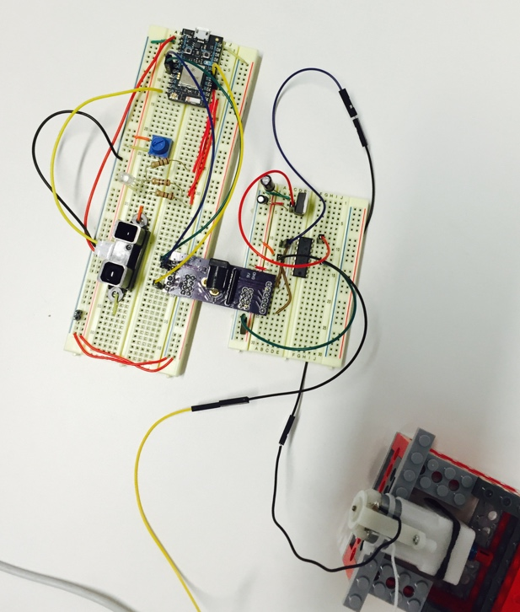

1. **A schematic of the device;**

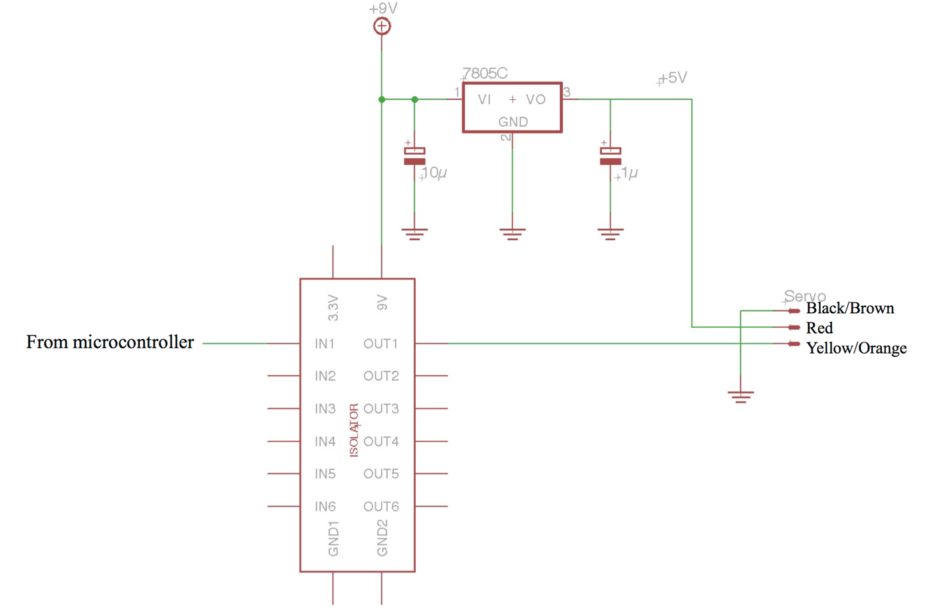

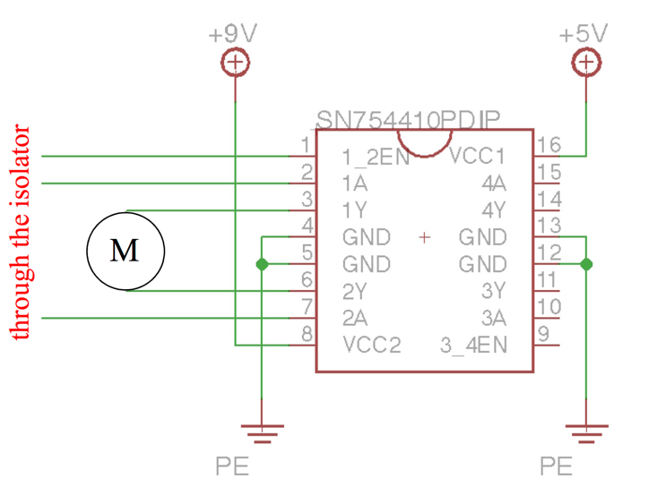

A4

A5

D3

1. **The code used for the device**

See the attachment. *Hoist.ino*

1. **Demo**

Part I (Layout Introduction). <https://youtu.be/rGRoGLT6-8E>

Part II (Device in action). <https://youtu.be/357KkJ2XrM0>